**A PRELIMINARY REPORT ON**

“**EMAIL ADMINSTRATION**”

SUBMITTED TO THE EDUBRIDGE INDIA PRIVATE LIMITED

**SUBMITTED BY**

**Miss : D. ISHA**  **Batch No: EON-5755**

**Under the guidance of**

**Amruta Deore**



**DEPARTMENT OF S PRAYAS CERTIFIED JAVA**

**FULL STACK DEVELOPER 02**

**EDUBRIDGE INDIA PRIVATE LIMITED**

**2021-2022**

**ACKNOWLEDGEMENT**

It gives all of us great pleasure in presenting the preliminary project report on “**Email Adminstration”**. With due respect and gratitude we would like to take this opportunity to thank internal guide for our project **Mrs. Amruta Deore** for giving us all the help and guidance we needed. We are really grateful for this kind of support. She has always encouraged us and given us the motivation to move ahead. He was put in a lot of time and effort in this project along with us and given us a lot of confidence. Also we wish to thank all the other people who have helped us in the successful completion of this project.

**ABSTRACT**

This Email Administration project is very useful to make process is very easy to generate specific email project for each and everyone. And generate random password .and the main purpose of the project is to generate specific Email and password.

**Chapter 1**

**INTRODUCTION**

* 1. **INTRODUCTION**

The objective of Email Administration is to develop a new and unique email id for each and every students for their first and last name based . And it is very useful to identify students details. This is very useful to make a process very easy . and in this project I have used one method to generate email id based the particular students given details . then I have use set department method, this is very useful to generate a email with the department code. In this project I have used more then 5 methods to make a perfect email administration project.

* 1. **SYSTEM REQUIREMENTS**
     1. **Software Requirements**

1.Operating System – Windows 10.

2.Platform – Eclipse

3.Languages – CORE JAVA.

**Chapter 2**

**MODULES**

**1.2.1 Generate Email :**

I have used this method to generate email for each new students.it is based on user first name and last name . and I got input from the user in run time.

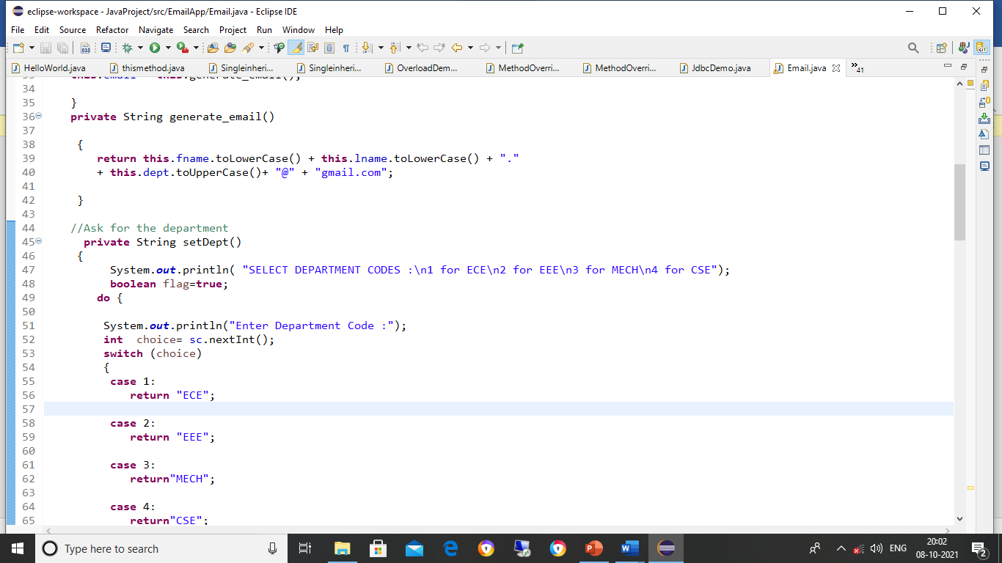

**1.2.2 Set Department :**

I have used this set department method to make the list of departments . it is very useful to select departments ,and it is very useful to generate the Email with the department details.

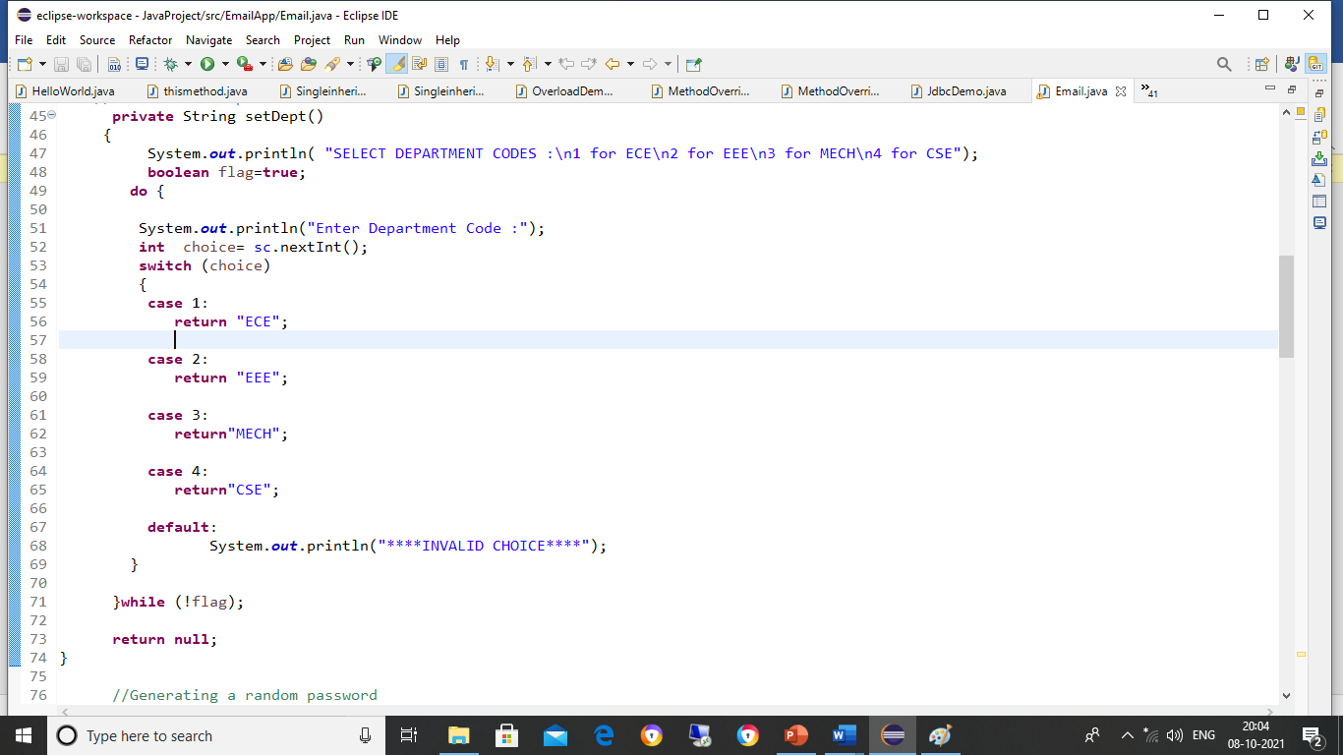

1.2.3  **Random Password :**

we can I have used this method to generate random password for each and every students . with the help of random password make our app is secure .

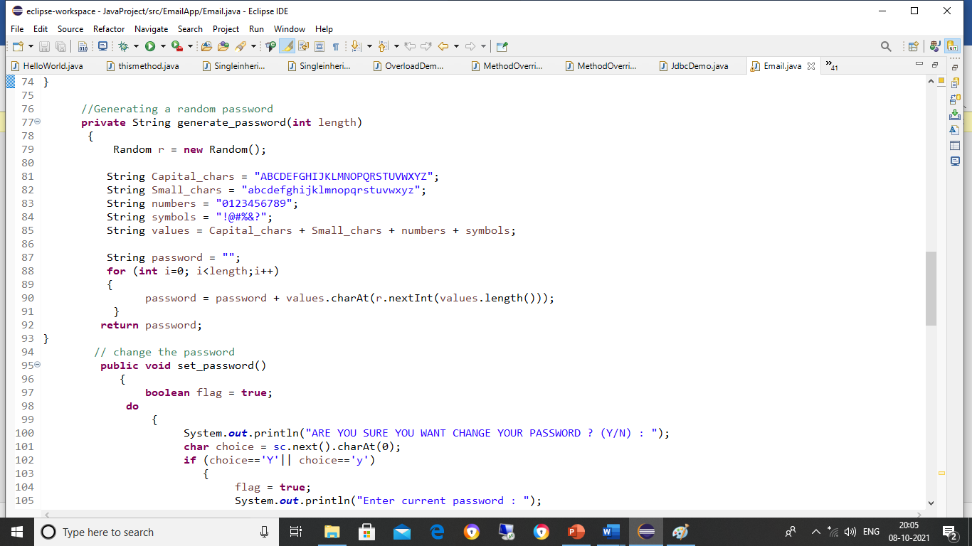

**1.2.4 Set Password :**

This method is very useful to set password . in this method we get a run time password from the user in run times . if suppose anyone feels my random password is not good, its difficult I couldn’t remember that ,for these kind of issues we can use this methods.

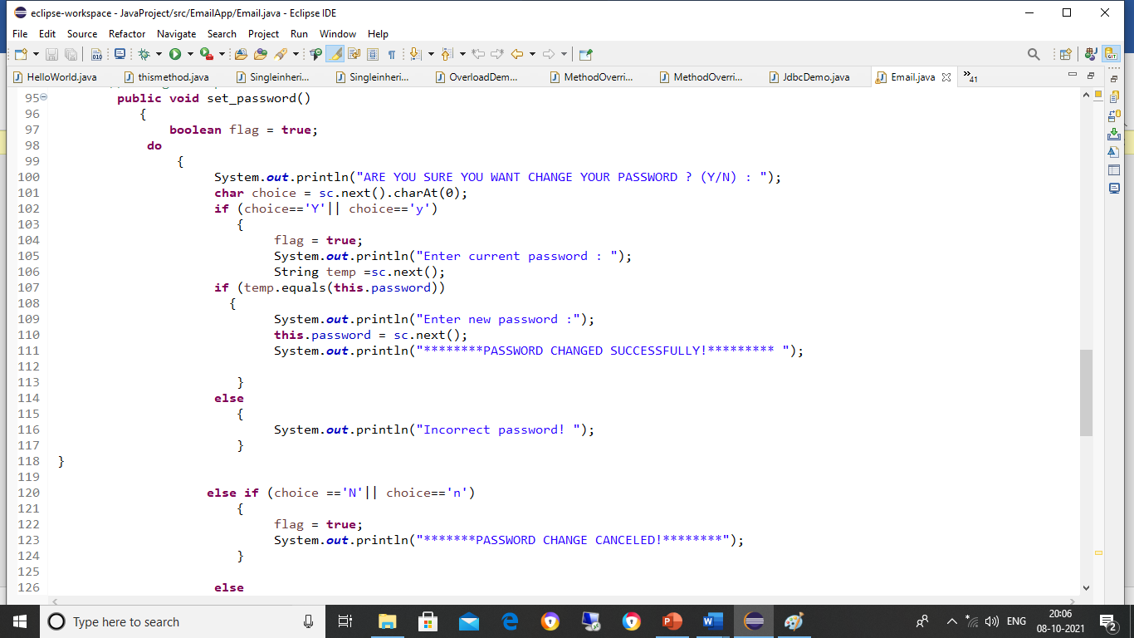

**1.2.5 Mail Capacity :**

I have used mail capacity method to set the capacity of mailbox. And I have made this method to get the value from the users because everyone need don’t need same size of mailbox , so that I have made it get the input from the users in run time.

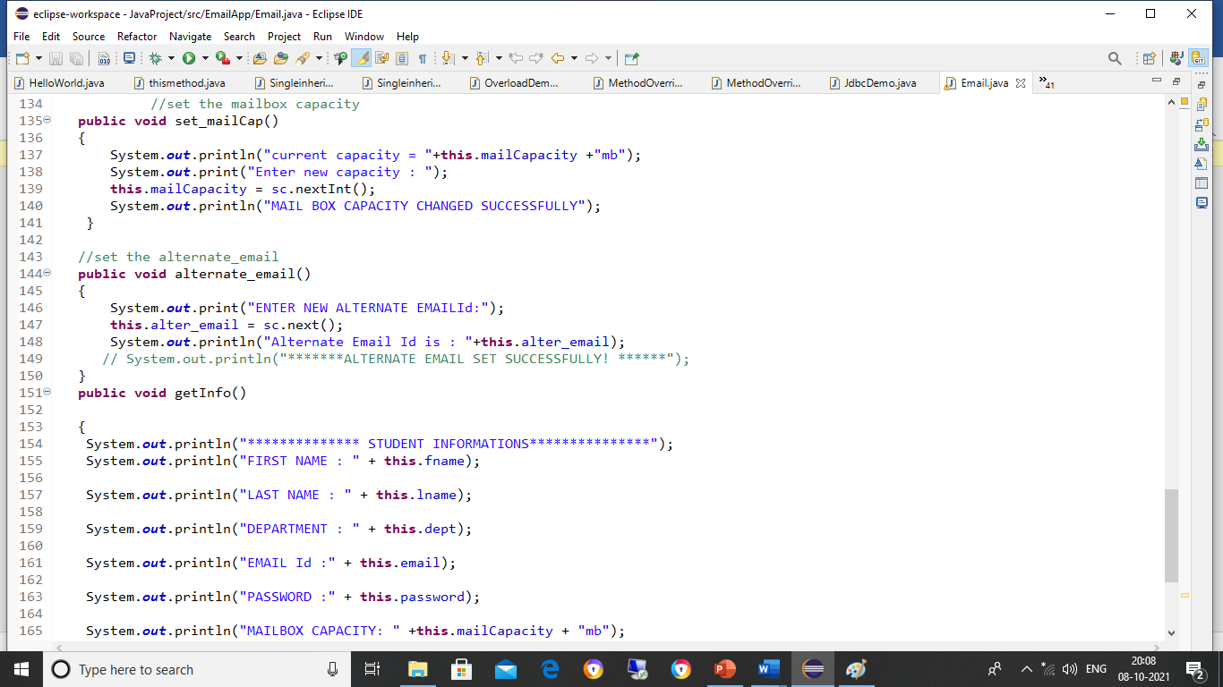

**Chapter 3**

**PROJECT IMPLEMENTATIONS**

**SCREEN 1 :**

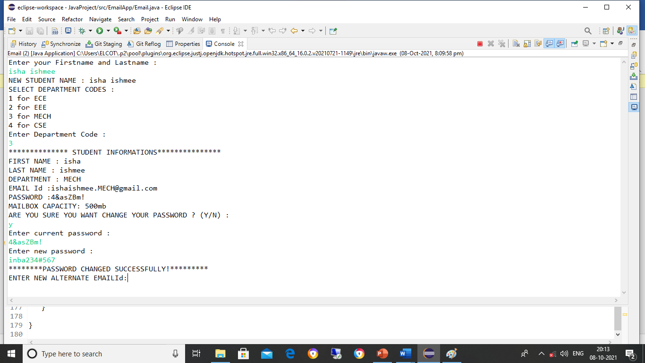

**SCREEN 2 :**



**SCREEN 3 :**



**SCREEN 4 :**



**CONCLUSION**

Email Administration Application will provide email and password details so that the organisation can uniquely access the Email address for communicating and also provides an option for changing password.